# CIS11 Project Part 1 Team Task Assignment

Team Name: Flying Spaghetti Monster

Team Members:

Samuel Elizarraras  
 Randy Son  
 Jason Ibrahim

Allocated Tasks for each member:

1. Multi-character input - Sam
2. Create stack for test scores ability to push/pop test scores
3. Analytical functions
   1. Minimum function - Jason
   2. Maximum function - Randy
   3. Average function - Sam
4. Convert data to readable text - Randy
5. Output to console

Projected Task Completion Timeline:

5/16/19: Samuel - Multi-character input

Randy - Create stack for test scores, pop stack into test score array

5/23/19: Minimum, maximum, and average function

5/29/19: Output data, test program

Flowchart  
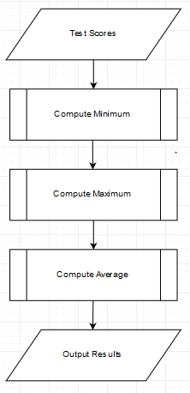

Pseudocode